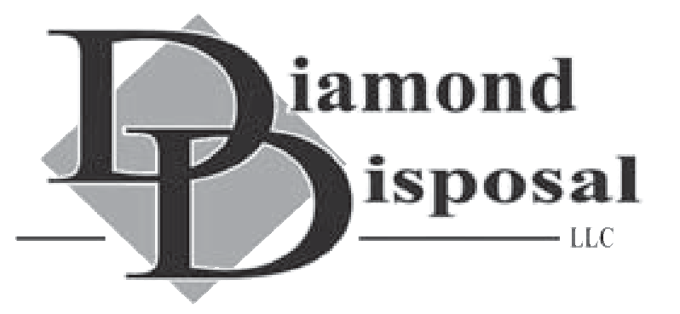
P.O. Box 327• Bechtelsville, PA 19505
610-845-1117

2023 BULK ITEMS POLICY
One standard bulk item per week is included with your service free of charge. Non-standard and hazardous items must be scheduled with our office and paid for in advance prior to removal. Please call the office 24 hours prior to your normal pick up day to schedule bulk.

Standard Bulk Items:

- End Table, Coffee Table, Small Love Seat, Ottoman, Vacuum Cleaner, Small Chair, Carpet (3 rolls cut into 4’ lengths), 1 Additional 32 Gallon Trashcan or 3 Bags for Additional Residential Waste (10-pound bag limit) (Construction debris does not apply).

Non-standard Bulk Items and Pricing:

- Large Dresser $15
- Dishwasher $15
- Toilet/Sink $15
- Water Softener Tank $20
- Grill $15
- Hot Water Heater $25
- Stove/Oven $25
- Queen/King Mattress $75
- Full/Twin Mattress $50
- Recliner $20
- Full Size Couch $25
- Reclining Couch $30
- Entertainment Center $25
- Washer/Dryer $25
- Exercise Machine $30
- Sectional Sofa (Whole) $60

Hazardous Waste and Pricing:

- Microwave $25
- Dehumidifier $25
- Window AC Unit $50
- Refrigerator/Freezer $75 (or Higher depending on size)

